**D. Y. Patil College of College of Engineering and Technology, Kolhapur**

**Department of Computer Science & Engineering**

**Class: SY-A Subject: AOOC**

**Experiment no: 15**

**Group No. 6 Mini Project**

**Title of Mini-Project: Crop Management System**

**Problem Statement:**

Farmers and agriculture students often face difficulties in selecting the most suitable crops for cultivation due to limited access to scientific soil analysis and crop compatibility information. In particular, understanding the relationship between soil pH levels and appropriate crop choices is crucial for maximizing yield and ensuring sustainable farming practices. To address this challenge, there is a need for a user-friendly tool that can analyze soil pH values and recommend suitable crops along with relevant information and visual guidance.

**Introduction:**

In modern agriculture, selecting the right crop based on soil characteristics is vital for achieving optimal yield and sustainable farming. One of the key factors influencing crop suitability is soil pH, which affects nutrient availability and plant growth.

To address this issue, a Crop Management System (CMS) has been developed as a GUI-based application using Java Swing. This tool assists users in identifying the most suitable crops for cultivation based on the input soil pH value.

* CMS is a GUI-based application developed in Java using Swing.
* It helps farmers and agriculture students identify suitable crops based on soil pH value.
* Displays crop information, suitable conditions, and images.
* Stores results in a file for record-keeping.

**System Architecture:**

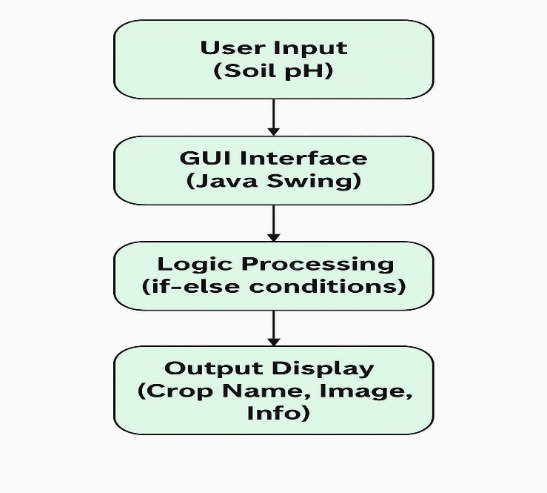

**Module description or working of system:**

1. User inputs soil pH value.
2. Button triggers crop check.
3. Application checks pH against predefined ranges.
4. Displays crop name, image, and detailed info.
5. Saves output to a file (cms_output.txt) for records.

**Screenshots:**

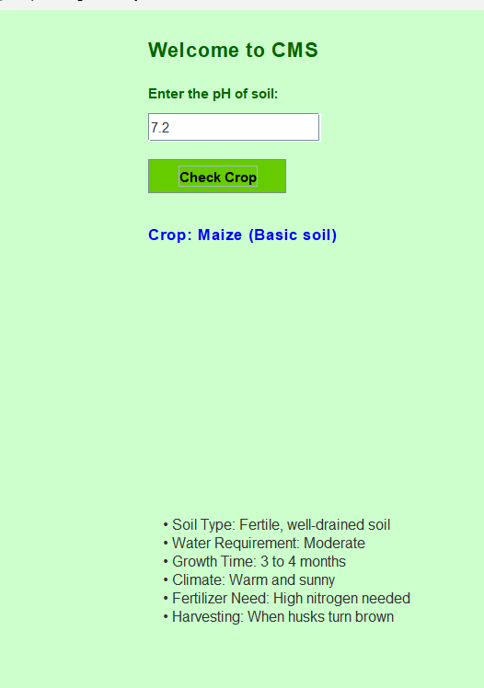

**Group Members:**

|  |  |  |  |
| --- | --- | --- | --- |
| **Unique id** | **Roll no** | **Name of Student** | **Sign** |
| **EN23231905** | **37** | **Suyog Vasudev Kumbhar** |  |
| **EN23194727** | **38** | **Vivek Pratap Zambre** |  |
| **EN23213305** | **39** | **Vishwajeet Amar Gavali** |  |
| **EN23216864** | **40** | **Swaroop Vilas Kashid** |  |